BLOB Handling (Basic Level)
Your content includes:
Jdbc_Image_Retrival
Jdbc_Pdf_Insertion_To_Database
Jdbc_Pdf_Retrival_From_Database
You only need basic understanding.
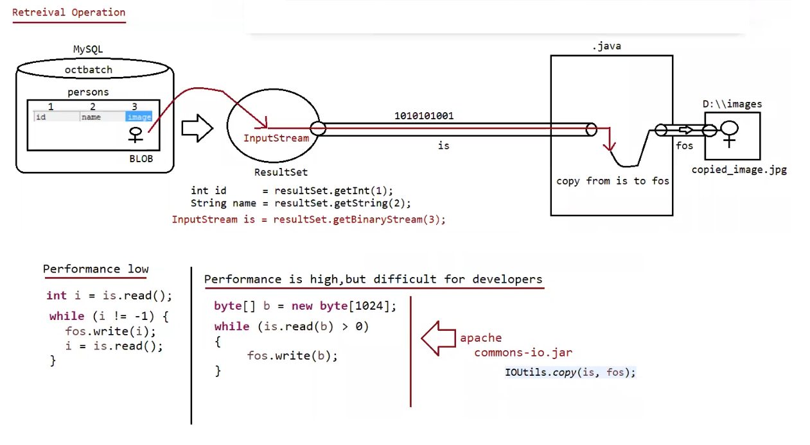

What is BLOB?
BLOB = Binary Large Object
It stores binary data like:
- images
- pdf files
- videos
Example column:
photo BLOB

Inserting file into DB
We use InputStream.
Example:
FileInputStream fis =
new FileInputStream("photo.jpg");
PreparedStatement ps =
con.prepareStatement(
"insert into persons values(?,?)"
);
ps.setString(1,"Pavan");
ps.setBinaryStream(2,fis);
ps.executeUpdate();

Retrieving file from DB
Your notes already show the idea.
InputStream is = rs.getBinaryStream(2);
FileOutputStream fos =
new FileOutputStream("new.jpg");
Then copy bytes.
Example:
byte[] b = new byte[2048];
while(is.read(b) > 0){
fos.write(b);
}

Eg: Jdbc_Image_Retrival
// go through the code

That's enough knowledge.
In modern systems files are usually stored in:
- AWS S3
- File servers
So DB BLOB usage is less common today.

Stored Procedures & CallableStatement
Your content explains:
CallableStatement
Stored Procedures
IN parameters
OUT parameters
INOUT parameters
You only need conceptual understanding.

What is Stored Procedure?
A group of SQL statements stored inside database.
Similar to method in programming.
Example:
CREATE PROCEDURE getProduct(IN id INT)
BEGIN
SELECT * FROM products WHERE pid=id;
END
Database stores it permanently.

Why stored procedures are used
Reasons:
1️⃣ Reusable SQL logic
2️⃣ Faster execution (compiled in DB)
3️⃣ Security (hide complex queries)
Usually written by DBA.

Java uses CallableStatement
To call stored procedure.
Example:
CallableStatement cs =
connection.prepareCall(
"{CALL P_GET_PRODUCT_DETAILS_BY_ID(?,?,?,?)}"
);
Then set parameters.
Example:
cs.setInt(1,2);

Register OUT parameters
Because procedure returns values.
Example:
cs.registerOutParameter(2,Types.VARCHAR);
cs.registerOutParameter(3,Types.INTEGER);
Then execute:
cs.execute();
Retrieve output:
String name = cs.getString(2);

Depth required for you
Just know:
- what stored procedure is
- why it is used
- CallableStatement usage concept
No need to memorize complex syntax.

Batch Processing (Moderately Important)
Your notes mention:
Batch_Update_Using_Prepared_Statement

Problem
If we execute 1000 queries:
1000 DB calls
Network overhead increases.

Solution: Batch Processing
Send multiple queries in one batch.
Example:
PreparedStatement ps =
con.prepareStatement(
"insert into student values(?,?)"
);
for(int i=1;i<=1000;i++){
ps.setInt(1,i);
ps.setString(2,"name"+i);
ps.addBatch();
}
ps.executeBatch();
Now DB receives all queries together.

Benefits
✔ Less network calls
✔ Better performance
✔ Used for bulk inserts
That's enough depth.

Eg: Batch_Update_Using_Prepared_Statement
// go through the code

Transaction Management
1️⃣ Concept Recap (Keep This)
A transaction is a group of database operations executed as one unit.
Example:
Bank Transfer
1. Debit sender account
2. Credit receiver account
Both operations must succeed.
If one fails → rollback everything.

2️⃣ Default JDBC Behaviour
By default JDBC works in AutoCommit mode.
Meaning:
Every SQL statement is committed automatically.
Example:
UPDATE account SET balance = balance - 1000
Immediately saved to DB.
But in transactions we disable AutoCommit.

3️⃣ Steps of JDBC Transaction
Step 1 Disable AutoCommit
connection.setAutoCommit(false);
Now database will not save changes immediately.

Step 2 Execute operations
stmt.executeUpdate(
"update account set balance = balance - 1000 where name='Ram'"
);
stmt.executeUpdate(
"update account set balance = balance + 1000 where name='Lakshman'"
);

Step 3 Commit
If both succeed:
connection.commit();
Now changes are permanently saved.

Step 4 Rollback (if error)
If any operation fails:
connection.rollback();
Database returns to previous state.

4️⃣ Simple Complete Example (Enough for Interviews)
Connection con = null;
Statement stmt = null;
try{
con = DriverManager.getConnection(url,user,pass);
stmt = con.createStatement();
con.setAutoCommit(false);
stmt.executeUpdate(
"update account set balance=balance-1000 where name='Ram'"
);
stmt.executeUpdate(
"update account set balance=balance+1000 where name='Lakshman'"
);
con.commit();
System.out.println("Transaction Successful");
}catch(Exception e){
con.rollback();
System.out.println("Transaction Failed");
}
This example is perfectly enough.
You do not need more complex code.

5️⃣ ACID Properties (Keep Short)
Property | Meaning
Atomicity | All operations succeed or none
Consistency | Database remains valid
Isolation | Transactions don’t interfere
Durability | Committed data is permanent

Eg: Jdbc_Transaction_App

Eg: Jdbc_Transaction_Savepoint_Rollback

